What are Teratogens?
Teratogens are similar to mutagens and carcinogens as they cause some form of mutation. However, teratogens are most significantly involved in causing mutation in the cells of a foetus. This just means the abnormality occurs in the womb to the already developing foetus as it would’ve been exposed to the agent during pregnancy. They can usually be picked up due to the commonness of the birth defect being seen.
Agents are considered mutagens and carcinogens if they don’t have teratogenicity abilities at an any exposure or if they cause more toxicity to the mother before the placenta or foetus. This means they don’t really have a direct effect on the reproductive toxicity, instead have a maternal effect [1].
A historical example in the 1960’s shows the use of the prescription drug of thalidomine being used to treat the morning sickness in the early stages of pregnancy. This drug exposure to the fetus showed cases of phocomelia, a congenital malformation that caused the arms and legs to be abbreviated to the hands and feet respectively [2].

Pregnancy and Teratogens – What to think about.
Posted: Tuesday 1st of May 2018.

Pregnancy and Teratogens
Pregnancy
Babys Health Online Directory

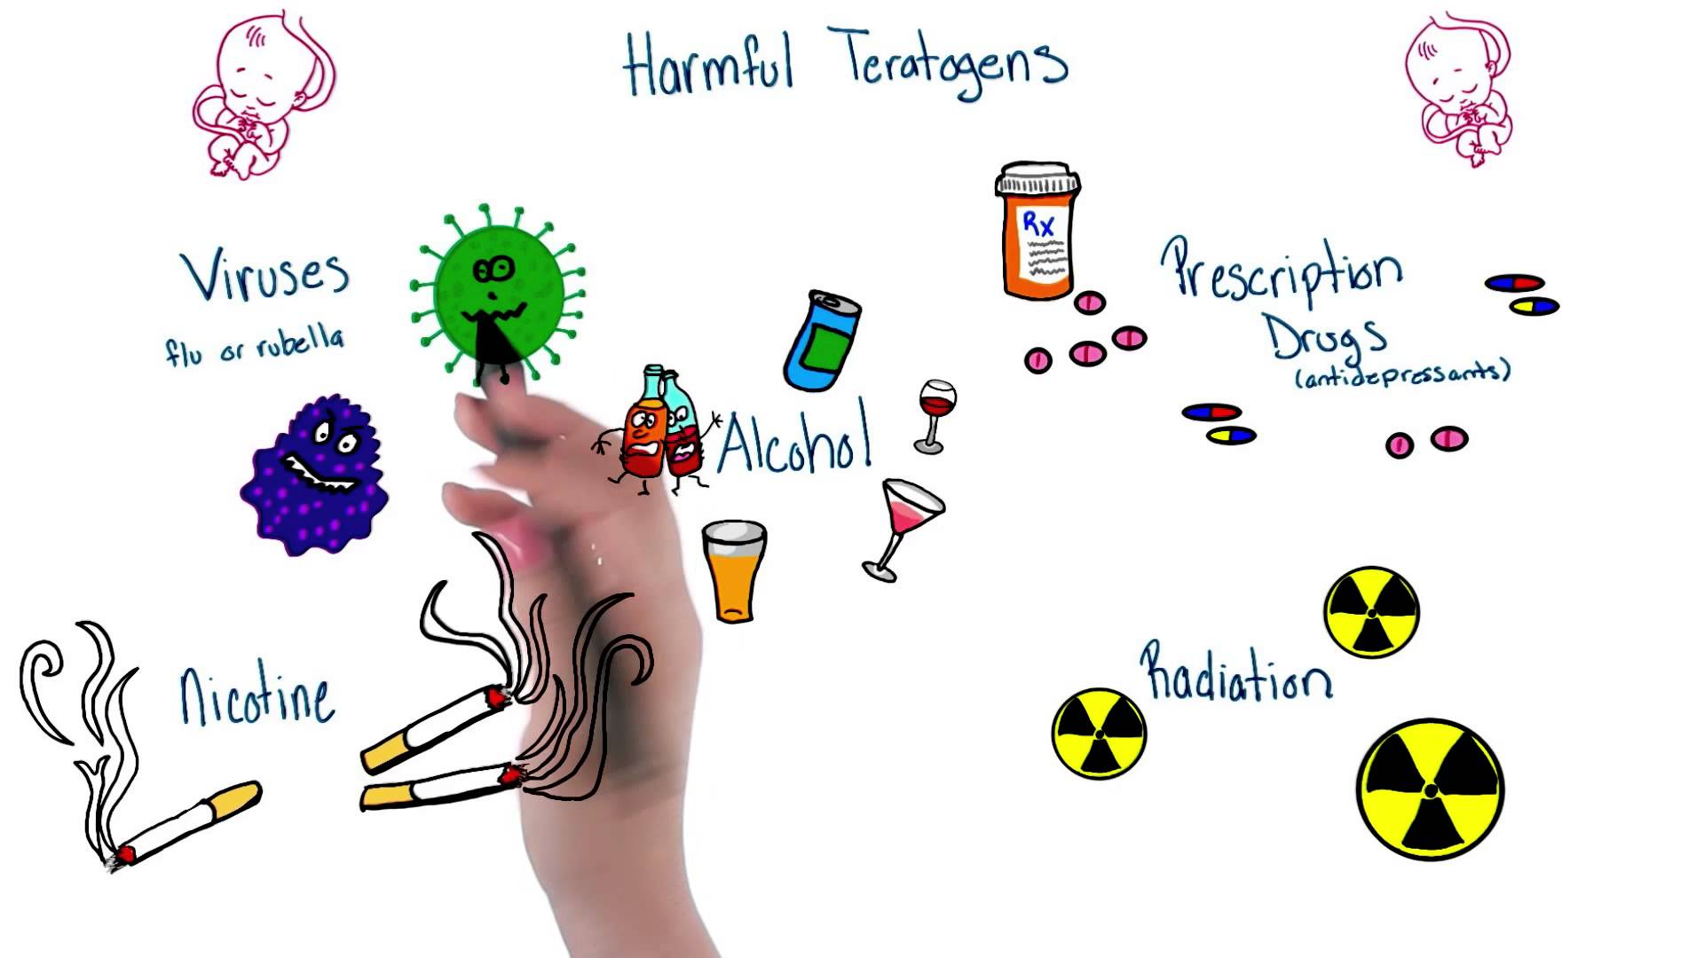
Have a look at this quick video on some harmful teratogens:

https://www.youtube.com/watch?v=jKnyEf81mo4
[3]

\

How exactly do these teratogens cause harm to the foetus?

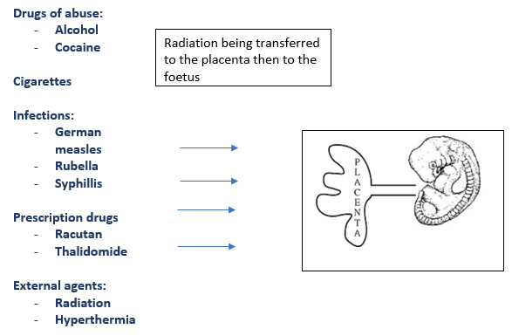

How does this relate to the stage of development?
Teratogens carry the ability to alter the fetus in its stage of development depending on its ability to cross the placenta to the foetus. So an agent such as the medication Heparin that can’t cross the placenta, isn’t teratogenic. The developmental effects of the teratogen on the fetus once its crosses the placenta will depend on what stage of development the embryo is in. It’s important to keep in mind that certain organs develop at different times, therefore the teratogen will have varying effect on the development depending on the time.

Keep in mind the effects of the teratogens are dependent on many other factors:

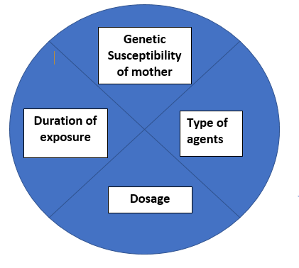

[4] [5]

PREVENTABLE TERATOGEN CAUSES:

Two leading causes of preventable birth defects in children are seen in mothers that smoke tobacco and drink alcohol [5].

The nicotine from tobacco causes hypoxia which is a reduced amount of oxygen supply reaching the tissues [6]. The result is a dysfunction in the placenta and constricting of blood vessels. Leading to nutrients not being provided to the foetus and resulting in a baby being underdeveloped and underweight[7].

[8]
The uniqueness of alcohol as a teratogenic agent is that it effects the central nervous system as a whole [9]. This means that at any time of the 9 month gestation it is able to cause birth defects and harmful health implications to the baby [10]. This also means that the first few weeks of pregnancy, before any clear symptoms of pregnancy are present the mother may be at risk of causing harm if she drinks alcohol[11]. Alcohol works as a teratogenic agent as it passes from the mother’s blood stream through to the placenta then to the foetus. The foetus is unable to breakdown alcohol as sufficiently as an adult, leading to high alcohol levels being maintained for longer. Fetal alcohol syndrome which is caused by maternal drinking of alcohol is the most common non- hereditary cause of mental retardation in the US[12].

References:
- Brent, R. L. (1986). Definition of a teratogen and the relationship of teratogenicity to carcinogenicity. Teratology, 34(3), 359-360.

- Vianna, F. S. L., Lopez-Camelo, J. S., Leite, J. C. L., Sanseverino, M. T. V., Dutra, M. da G., Castilla, E. E., & Schüler-Faccini, L. (2011). Epidemiological Surveillance of Birth Defects Compatible with Thalidomide Embryopathy in Brazil. PLoS ONE, 6(7), e21735. http://doi.org/10.1371/journal.pone.0021735

Udacity. (2015, February 23). Harmful teratogens - Intro to Psychology. [Video files]. Retrieved from https://www.youtube.com/watch?v=jKnyEf81mo4.

- Rasmussen, S. A. (2012). Human teratogens update 2011: can we ensure safety during pregnancy?. Birth Defects Research Part A: Clinical and Molecular Teratology, 94(3), 123-128.

- Genetic, A., & District of Columbia Department of Health. (2010). Understanding Genetics: a District of Columbia Guide for Patients and Health Professionals.

- Andrade, S. E., Gurwitz, J. H., Davis, R. L., Chan, K. A., Finkelstein, J. A., Fortman, K., ... & Yood, M. U. (2004). Prescription drug use in pregnancy. American Journal of Obstetrics & Gynecology, 191(2), 398-407.

- Haustein, K. O. (1999). Cigarette smoking, nicotine and pregnancy. International journal of clinical pharmacology and therapeutics, 37(9), 417-427.

- If You are a New Mother, Breastfeed Your Child to Reduce Smoking - Estanara Magazine. (2015, April 21). Retrieved from http://e-newsletter.pdpi.pk/?p=543

- Beers, M. H., Fletcher, A. J., Jones, T. V., Porter, R., Berkwitz, M., & Kaplan, J. L. (2003). The Merck manual of medical information. Pocket Books.

- Pangle, B. L. (2006). Drugs in pregnancy and lactation. Text book of Therapeutics, Drug and Disease Management. 8th ed. Philadelphia: Lippincott William Wilkins, 434-48.

- Floyd, R. L., Decouflé, P., & Hungerford, D. W. (1999). Alcohol use prior to pregnancy recognition 1. American journal of preventive medicine, 17(2), 101-107.

- May, P. A., & Gossage, J. P. (2001). Estimating the prevalence of fetal alcohol syndrome: A summary. Alcohol Research and Health, 25(3), 159-167.

