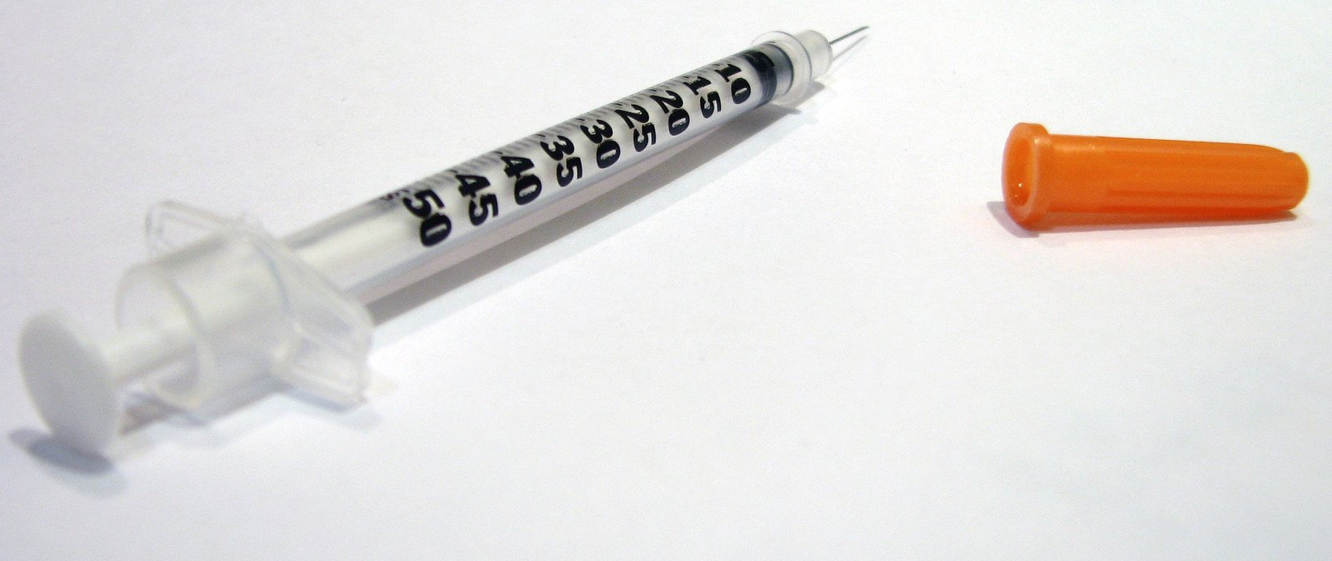

Kinase Linked Receptors
Alana Freeman-Angove

Drugs are substances which have a physiological effect when introduced into the body, but why? This blog looks at one path a drug might take to do what we need it to do.

What are they?

Kinase Linked Receptors or KLRs are a type of cell-surface receptor; essentially a ‘smart’ protein which sits on the surface of our cells waiting to be used. Like all receptors, KLRs receive a signal from the environment, in the form of a drug, and instruct the cell to carry out a task. They not only convey these vital messages, but also act as enzymes, meaning they can catalyse or speed up reactions occurring in our cells.

KLRs sit in the membrane of cells, and each have an outside-the-cell part and an inside-the-cell part. The outside part is where there is space for a drug to dock itself into the receptor, and the inside part is where the reactions happen. KLRs are partial to living in pairs, and they can always be found fairly close to one another. This is an interesting trait for a receptor and it is key to how they work to convey the messages from the drug to the cell.

How Do They Work?

With a rough idea of where they are and what they look like, we can look at how they get the message from outside the cell to inside the cell. When a drug docks into the KLR, the signal pathway is started. Two docked receptors come together and become active and the two inside-the-cell parts line up next to one another.

KLRs have an interesting “you scratch my back, and I’ll scratch yours” situation. The enzymatic part of one receptor phosphorylates (adds phosphorous molecules to) the other receptor, and this occurs on both sides. Once both receptors have phosphorous molecules on them, they are open for business.

Proteins of certain types can attach themselves and use the phosphorous molecules to activate themselves. These now active proteins carry out the next steps in the signal pathway and continue to pass the message onto the cell. The signal pathway usually ends in the nucleus of the cell and affects gene transcription.
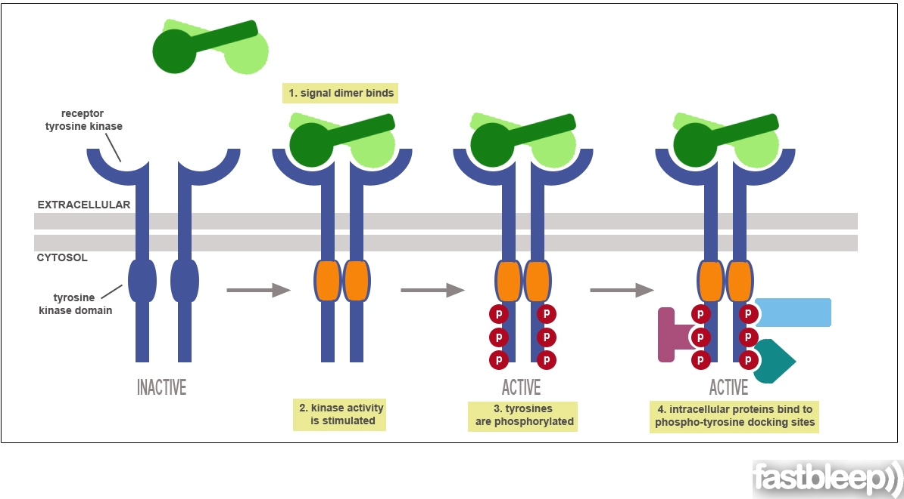

Why Do We Care?

If KLRs aren’t working properly, the cell is not growing, differentiating or surviving correctly, and the body’s functioning can be greatly affected. KLRs most commonly bind growth factors or hormones, both important in making sure our bodies grow and survive properly.

Insulin is a vital hormone in our bodies, which is made by beta cells in the pancreas. When we eat, insulin is released into the blood stream where it helps to move glucose from the food we have eaten to cells, where it can be used as energy.

The insulin receptor is one of many that belong to the KLR family. In this case, insulin is the drug which docks into the receptor on the outside of the cell. The insulin receptor, by useful coincidence, happens to already exist in pairs in our bodies, so is activated pretty quickly. The inside-the-cell part (enzyme part) is activated, and the two receptors can start to cross-phosphorylate. The phosphorus molecules allow specific proteins to bind to the structure, where they are then activated. These activated proteins pass the message on. The message in the case of insulin, is telling the body to increase the rate of glycolysis (break down of glucose) so the cells around the body can use the glucose from the food as energy.

One of the most common diseases in the modern world is diabetes, which is characterised by a lack of insulin production in the body or production of unusable insulin. Both types result in high blood-glucose levels, which if left untreated can result in damage to vessels that supply blood to vital organs, increasing the risk of heart disease, strokes, kidney disease, vision problems and nerve problems.

Insulin is given to patients with high blood-glucose levels in order to activate the KLR and therefore lower their blood-glucose levels. KLRs are one of many pathways a drug may take to get their message to our bodies, and one that many patients take for granted each day. It is the modern drugs like these and our understanding of how they work that drives our ever-growing pharmaceutical industry.

**Please note that references have not been added yet, and a hand drawn image will be used to replace the second image as to avoid copyright issues. Also open to any witty title suggestions.**

